Margaret Nash
author of

Women’s Education in the United States, 1780-1840



Wednesday, January 17, 2007  3:15 – 4:30 PM
(951) 827-3233
Special Collections – 4th floor Rivera Library

Refreshments will be served
UCR Libraries’

Author Series
at Special Collections 

Rivera Library
University of California
Riverside

Margaret Nash is a professor in the Graduate School of Education at the University of California, Riverside. Professor Nash specializes in the history of curriculum and gender and education. She will speak on her groundbreaking book Women’s Education in the United States, 1780-1840. The 2005 recipient of the Critics Choice Book Award of the American Educational Studies Association, the book examines the underlying rationale for educating women (“Is Not Woman a Human Being?”) In this history of the institutions that were the forerunners of the women’s college movement, Professor Nash considers the social, economic, and political forces that led to the admission of women to universities—a privilege taken for granted by most young women today.

Margaret Nash’s book will be available for sale,
courtesy of the UCR Bookstore.
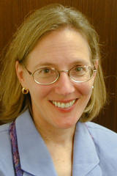
Margaret Nash

