Clare Spark
author of

Hunting Captain Ahab: Psychological Warfare and the Melville Revival



Wednesday, November 15, 2006  3:15 – 4:30 PM
Special Collections – 4th floor Rivera Library
(951) 827-3233

Refreshments will be served
UCR Libraries’

Author Series
at Special Collections 

Rivera Library
University of California
Riverside

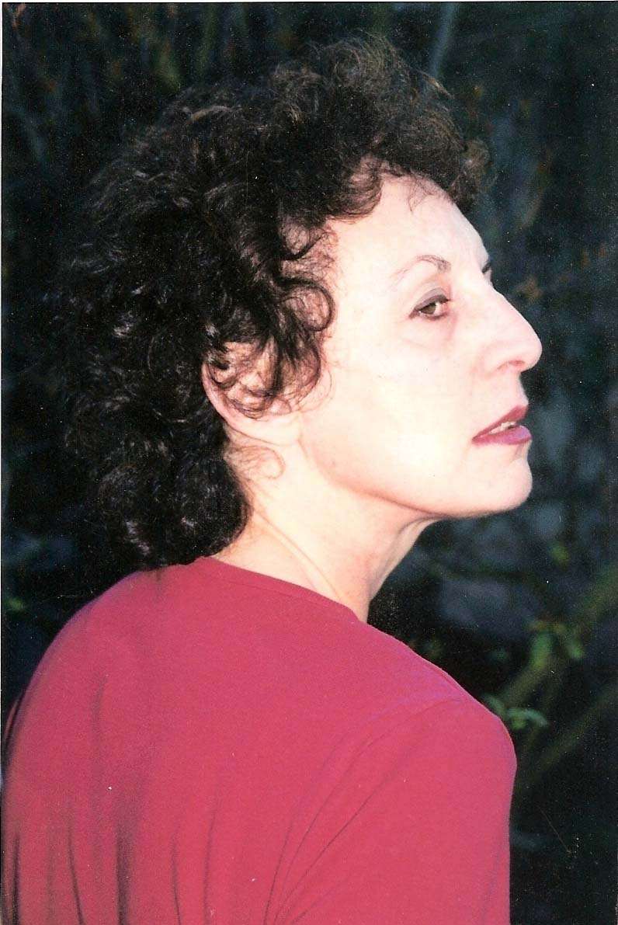
Dr. Clare Spark, an independent scholar and past program director of Pacifica Radio, Los Angeles, is famous for her iconoclastic analyses of the American scholarly community. The author of numerous articles and two critically-acclaimed books, she will speak on her work Hunting Captain Ahab: Psychological Warfare and the Melville Revival. In this boldly original study, Dr. Spark examines Melville scholarship and its enmeshment in political and institutional agenda. Uncovering what she describes as a “pattern of censorship” that resulted in a serious misunderstanding of Melville, Dr. Spark presents a surprising—and totally convincing—reinterpretation of the vexed figure of Captain Ahab.

Clare Spark’s book will be available for sale,
courtesy of the UCR Bookstore.
Clare Spark

