The Knox and Carlotta Mellon
Lecture Series in Public History
University of California, Riverside
Department of History,
Center for Ideas & Society, Department of Ethnic Studies, Film & Visual Culture Program, and California Museum of Photography, with the Riverside Metropolitan Museum
Present
Robert Gonzales Vasquez
M.A., History, UCR, 1993
Founder, Inland Mexican Heritage

“Living on the Dime:
Inland Southern California in Transition”
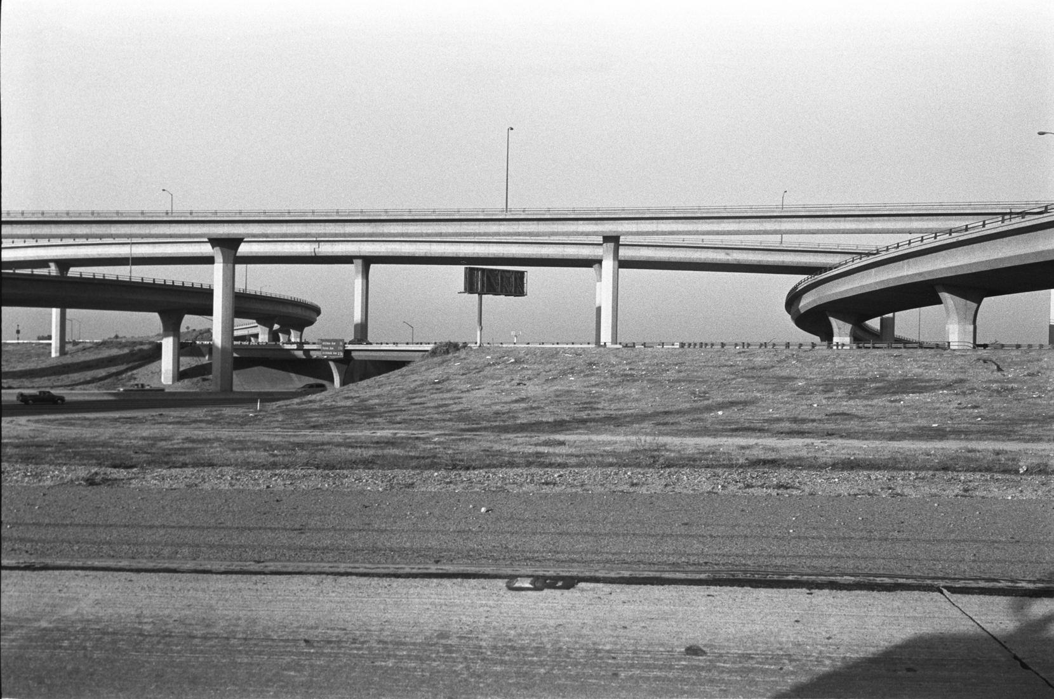

A multimedia regional heritage project that explores the social, political, economic, and environmental impact of the Interstate 10 freeway. Through stories, photos, and film, “Living on the Dime” tells of the diverse people and communities along a 200-mile stretch of the I-10, from Blythe to Bloomington.

Thursday, November 9, 2006
3:30 p.m.
1500 HMNSS on the UCR Campus
Reception to Follow

