Please join the Department of English
for a talk to be given by:

Frances Smith Foster



Emory University

"'Til Death or Distance Do Us Part'“: Love and Marriage in
Early African America”
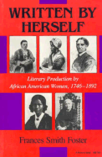
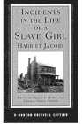
“Harriet Jacobs once wrote "Why does a slave ever love"? but her narrative shows many examples of love, marriage and family ties among enslaved people. Henry Bibb escaped from slavery but returned to get his wife and child, not once but three times. They are not unique. Contrary to many histories and assumptions, early African American print culture is filled with songs, poems, stories, essays, letters and memoirs that show antebellum African Americans, whether enslaved or free, not only married but expected such marriages to endure. This presentation offers examples of this evidence and argues the importance of the Afro-Protestant press for an accurate and inclusive understanding of our historical past.”

Wednesday, November 1, 2006
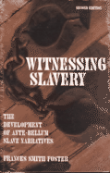
2:00pm

HMNSS 1500
Refreshments will be served.

