CHIAPAS MEDIA PROJECT/PROMEDIOS

FILM SCREENING AND DISCUSSION WITH ALEXANDRA HALKIN

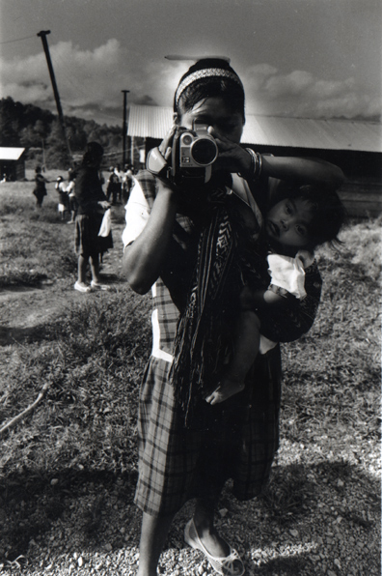
Since 1998 the Chiapas Media Project, a bi-national partnership, has been providing video and computer equipment and training to indigenous and campesino communities in Chiapas and Guerrero, Mexico. The objective has been to provide these communities with the means to produce their own media and distribute it.

Alexandra Halkin has been a documentary producer for the last 25 years. Alexandra is the Founding Director of Chiapas Media Project/Promedios and is currently responsible for promoting the CMP/Promedios videos internationally. In 2004 she was the recipient of a Guggenheim fellowship.

Wednesday, April 5, 2006
University of California, Riverside
HMNSS 1500
4:30-7 pm
Free and open to the public

Generously co-sponsored by: Film and Visual Culture Program, Latin American Studies Program, Department of Hispanic Studies, and the Women’s Studies Department.

For more information please contact Freya Schiwy (freyasch@ucr.edu) / (951) 827 1468

