The UC Multi-Campus Research Group in Late Antiquity and
UCR Departments of History and Religious Studies
present:

Professor Elizabeth Clark

John Carlisle Kilgo Professor of Religion and
Director of the Graduate Program in Religion Duke University

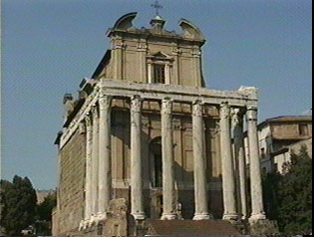

“Rome in the Nineteenth-century Imaginary:
The Professors, the Pagans
and Early Christianity”

Friday, March 17, 2006

4:00 pm.
Humanities 1500

Reception to follow
Elizabeth Clark is one of America’s foremost historians of early Christianity. She is a member of the American Academy of Arts and Sciences, a past president of the American Academy of Religion, of the American Society of Church History, and of the North American Patristics Society. She founded the methodologically innovative Journal of Early Christian Studies. Her publications in the fields of ancient Christianity and Feminist Studies have led her, in her more recent work, to analyze the place of theory in constructing historical theology. Her recent books include The Origenist Controversy: The Cultural Construction of an Early Christian Debate (Princeton University Press, 1992); Reading Renunciation: Asceticism and Scripture in Early Christianity (Princeton University Press, 1999), and her sweeping last book, History, Theory, and the Study of Early Christianity (Harvard University Press, 2003).
For directions or further information, contact the UCR History Dept. (951) 827-1439.

