The Mellon Workshop on Medieval and Postmodern Legacies, The Department of English and the Center for Ideas and Society
Present:
SETH LERER

Stanford University

Postcolonial and Postmodern in Contemporary Medieval Studies

Date: Thursday, January 26, 2006
Time: 4:10 PM

Location: Humanities & Social Sciences Building 2212 (English Department Conference Room)
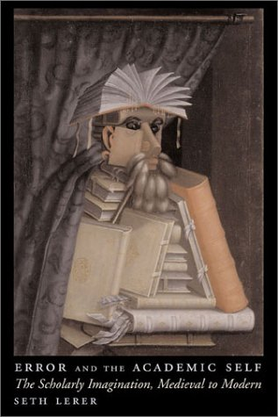
Seth Lerer is the Avalon Foundation Professor in Humanities and Professor of English and Comparative Literature at Stanford University. He has published seven books, including Chaucer and His Readers (Princeton, 1993;) and Courtly Letters in the Age of Henry VIII (Cambridge ,1997), and he is the author of more than forty scholarly articles and reviews. Professor Lerer has received many awards for his scholarship and teaching, including fellowships from the National Endowment for the Humanities and the Guggenheim Foundation, the Beatrice White Prize of the English Association of Great Britain, as well as the Hoagland Prize for undergraduate teaching at Stanford. Open to the Public
Admission: Free/ Contact: J. M. Ganim, Professor, English 2-1540, john.ganim@ucr.edu

