Screening and Presentation by Documentary Filmmaker and Author

Maureen Gosling

Monday, January 23, 2006 3:40 – 5 pm HMNSS 1500

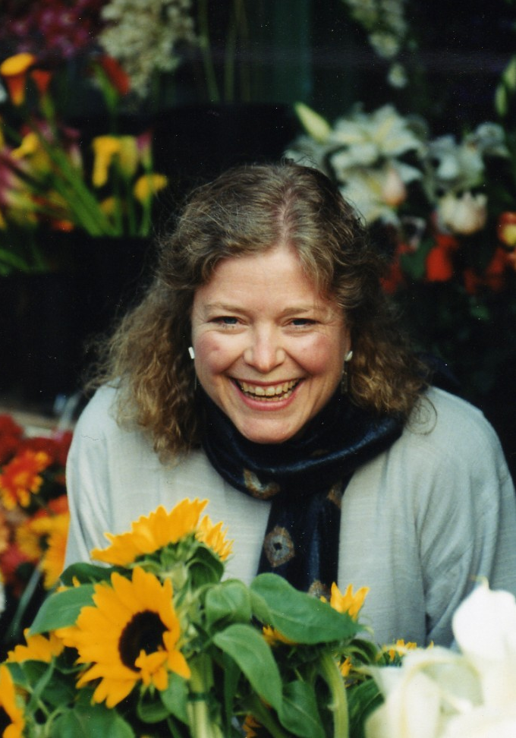 | Maureen Gosling will screen  A SKIRT FULL OF BUTTERFLIES  and discuss her experiences making and showing films in indigenous and other communities. Included will be observations on the reaction to the building of a Walmart in Juchitan, where Gosling filmed Blossoms of Fire and Skirt Full of Butterflies.
Maureen Gosling has been a prolific editor and independent filmmaker for more than thirty years. She has collaborated with Les Blanc, Jed Riffe, Tom Weidlinger, Shakti Butler, Pam Rorke Levy, and others.  Gosling’s debut feature documentary Blossoms of Fire, won the coveted Coral Award for Best Documentary by a Non-Latino Director about Latin America at the Havana International Film Festival.  Her presentation at UCR will be followed by a public screening of Blossoms of Fire and conversation with Maureen Gosling at the  Riverside Public Library  Monday, January 23 2006. 6:30 pm | 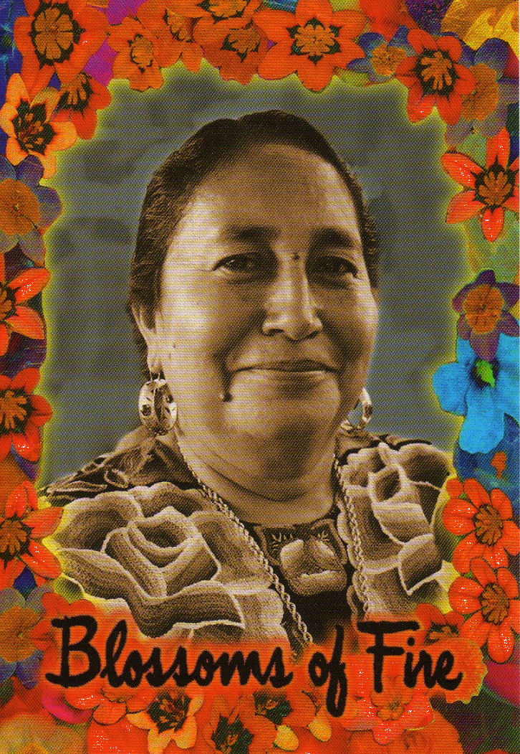

For more information please contact Freya Schiwy (freyasch@ucr.edu)

