Michelle Bloom
author of

Waxworks: A Cultural Obsession

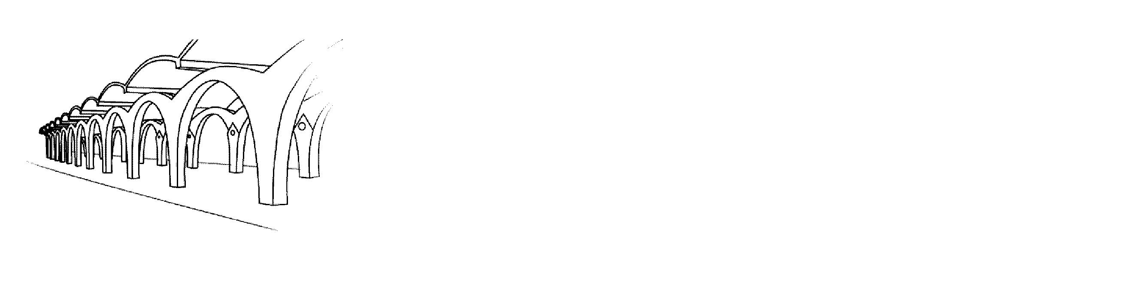

Wednesday, October 19, 2005  3:15 – 4:30 PM

Special Collections – 4th floor Rivera Library

Refreshments will be served.
UCR Libraries’

Author Series
at Special Collections 

Rivera Library
University of California
Riverside

Michelle E. Bloom is an Associate Professor of French and Comparative Literature at the University of California, Riverside, where she directs the Comparative Literature Program and teaches comparative and world literature, film and French. Her book Waxworks: A Cultural Obsession was published by the University of Minnesota Press in 2003. Professor Bloom has published articles on Balzac and Champfleury, Henry James and François Truffaut, and Emile Zola as well as articles on silent film and "Pygmalionism" in such journals as the Association of Departments of Foreign Languages Bulletin, Comparative Literature, Literature/Film Quarterly and Symposium. She is currently working on a book tentatively entitled Beyond Orientalisms : France and Asia in Film, Literature and Culture.

Professor Bloom’s book will be available for sale,
courtesy of the UCR Bookstore.
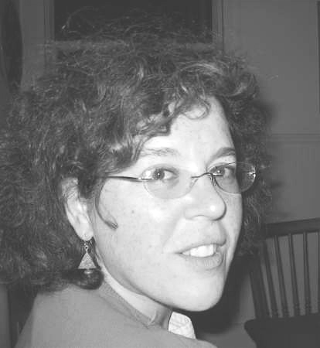
Michele Bloom

