The Mellon Workshop on Medieval and Postmodern Legacies and the Center for Ideas in Society
Present a lecture by
JOHN TOLAN

University of Nantes, France

ST. FRANCIS AND THE SARACENS

Date: Thursday, May 19
Time: 4:00 PM

Location: Humanities & Social Sciences Building 1303 (History Library)
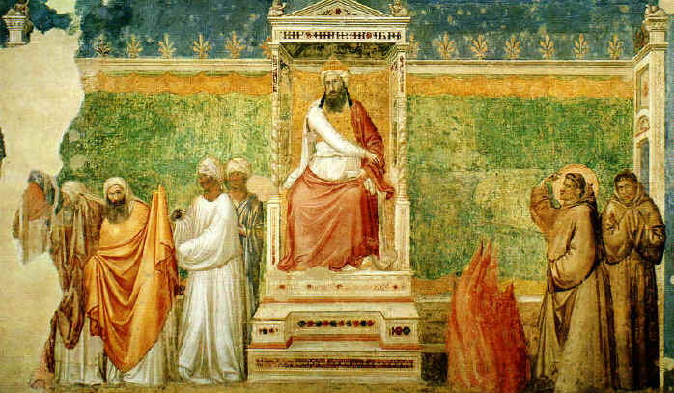
JOHN TOLAN is a professor of history at the University of Nantes, in France. He is the author of several widely acclaimed books, including Saracens: Islam in the Medieval European Imagination. New York: Columbia University Press, 2002. Petrus Alfonsi and his Medieval Readers. Gainesville: University Press of Florida, 1993 and Medieval Christian Perceptions of Islam: A Book of Essays. New York: Garland Press, 1996.
Open to the Public
Admission: Free/ Contact: J. M. Ganim, Professor, English 2-1540

