The Mellon Workshop on Medieval and Postmodern Legacies and the Center for Ideas in Society
Present a lecture by

Michelle Szkilnik

University of Nantes, France

PROFESSING WAR:

Jean de Bueil's Jouvencel

Date: Friday, May 20
Time: 3:00 PM

Location: Humanities & Social Sciences Building 1303 (History Library)
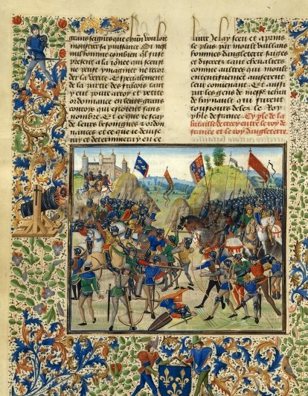MICHELLE SZKILNIK is professor of literature at the University of Nantes in France. She has published widely on medieval French literature and language, especially legends and narratives of the Holy Grail. She is presently a Fellow at the Oregon Institute for the Humanities, where she is preparing an edition of Jean de Bueil’s Jouvencel.

Open to the Public
Admission: Free/ Contact: J. M. Ganim, Professor, English 2-1540

