The Mellon Workshop on Medieval and Postmodern Legacies and the Center for Ideas in Society
Present a lecture by
L. O. ARANYE FRADENBURG

Professor of English, UCSB

The Aesthetic Turn in Chaucer Criticism

Date: Friday, May 13
Time: 3:00 PM

Location: Humanities & Social Sciences Building 2212 (English Department Conference Room)
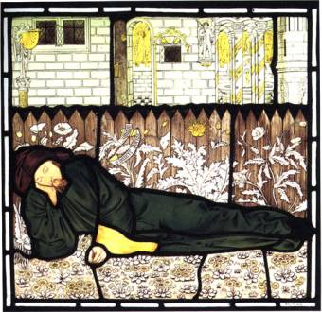 L. O. Aranye Fradenburg is a Professor in the English Department at the Unversity of California, Santa Barbara. She received her Ph.D. from the University of Virginia in 1982. Her central interests include Medieval English and Scottish literature; and critical and historical theory. She is the author of City, Marriage, Tournament: Arts of Rule in Late Medieval Scotland (1991), as well as of many classic articles on Chaucer, Dunbar, Henryson, and psychoanalysis and medieval studies, including the most influential article ever written on Chaucer’s Wife of Bath. She is the editor of Women and Sovereignty (1992), and, with Carla Freccero, of Premodern Sexualities (1996). Her recent book Sacrifice Your Love employs Zizek and Lacan to understand medieval literature.

Open to the Public
Admission: Free
Contact: J. M. Ganim, Professor, English 2-1540

