The Mellon Workshop on Medieval and Postmodern Legacies and the Center for Ideas in Society
Present a lecture by

PATRICK GEARY

Professor of History, UCLA.

NATIONALISMS MEDIEVAL AND MODERN

Date: Wednesday, February 23
Time: 12:10-1:00 PM

Location: Humanities & Social Sciences Building 1500
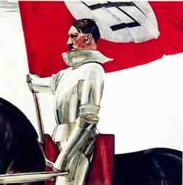
PATRICK GEARY is the author of many books, including The Myth of Nations: The Medieval Origins of Europe; Phantoms of Remembrance: Memory and Oblivion at the end of the first Millennium; Living with the Dead in the Middle Ages; and others. His books have been translated into French, German, Japanese, Korean and other languages. He holds a Phd from Yale University and has been awarded fellowships from the NEH, the Guggenheim Foundation and the Max Planck Institute.

Open to the Public
Admission: Free
Please Announce to Your Classes

