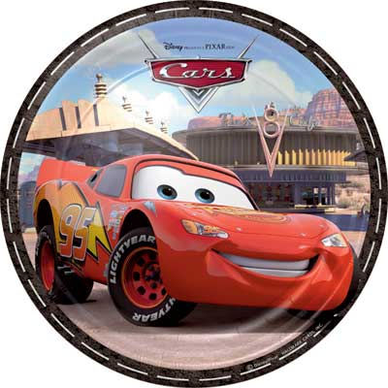
Cars, Trucks, Snakes, Creepy Crawlers

And oh, so much more

That’s what his mom has in store!

It’s a Baby Shower for
Luisa Rodriguez

Tuesday, February 12, 2008
2:00-4:00 p.m.
VCSA-2120 Hinderaker Hall

R.S.V.P - kathleen.hernandez@ucr.edu
By February 7th

Registered at Target and Babies R Us

