Douglas Kearney Nicelle Davis
Red Hen & ACF-LA at Boston Court
Moderated by: Brendan Contantine
November 27, 2012 7:00 pm

Boston Court Performing Arts Center strives to challenge the audiences of Pasadena and the San Gabriel Valley with diverse programs in an intimate setting. Please join Red Hen Press and ACF-LA for an evening with celebrated writers Douglas Kearney and Nicelle Davis and musicians from the American Composers Forum–LA, with moderator Brendan Constantine. General admission will be $10, with a discounted rate of $5 for students, and seniors. For more information, please contact Red Hen Press at publicity@redhen.org.

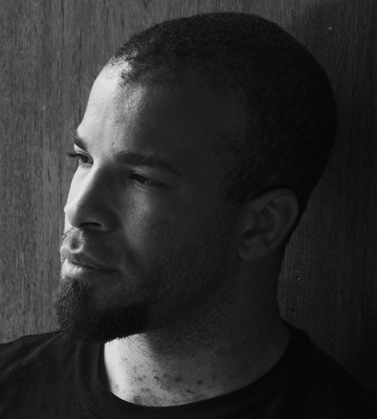
Douglas Kearney’s first full-length collection of poems, Fear, Some, was published in 2006 by Red Hen Press. His second manuscript, The Black Automaton, was chosen by Catherine Wagner for the National Poetry Series and published by Fence Books in 2009. In 2008, he was honored with a Whiting Writers Award. An Idyllwild and Cave Canem fellow, Kearney has performed his poetry at the Public Theatre, Orpheum, and The World Stage. His poems have appeared in journals such as Callaloo, jubilat, nocturnes, Ninth Letter, Washington Square, and Gulf Coast. Born in Brooklyn, now living in Santa Clarita, he has a BA from Howard University and an MFA in Writing from the California Institute of the Arts, where he now teaches courses in African American poetry, myth, hip hop, and opera.
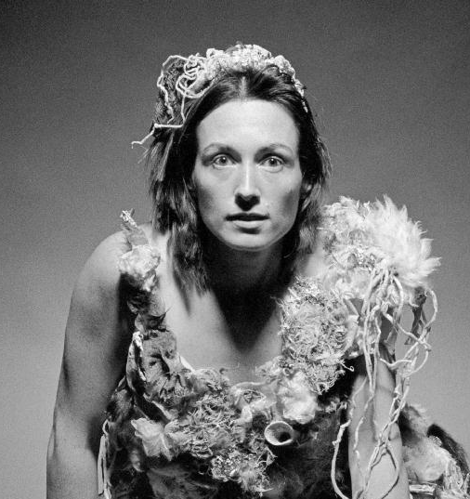
Nicelle Davis resides in Lancaster, California, with her son J.J. She has taught poetry at Youth for Positive Change, an organization that promotes success for youth in secondary schools, with Volunteers of America in their Homeless Youth Center, and MHA. She currently teaches at Antelope Valley College. Her poems have appeared or are forthcoming in The Beloit Poetry Journal, The New York Quarterly, PANK, SLAB Magazine, Two Review, and others. Her first collection of poems, Circe, is available from Lowbrow Press and In the Circus of You will be released from Rose Metal Press in 2014. You can read her e-chapbooks at Gold Wake Press and Whale Sound. She is an assistant poetry editor for Connotation Press and runs a free online poetry workshop at The Bees’ Knees
Blog. Her newest collection, Becoming Judas, will be available from Red Hen Press Fall 2013.
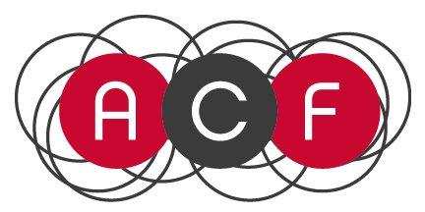
The American Composers Forum-LA supports the artistic and professional growth of composers and expands the markets for new music through audience building, advocacy, community educational programs, visibility, workshops, composer residencies, and grants for new music projects.

Moderator:
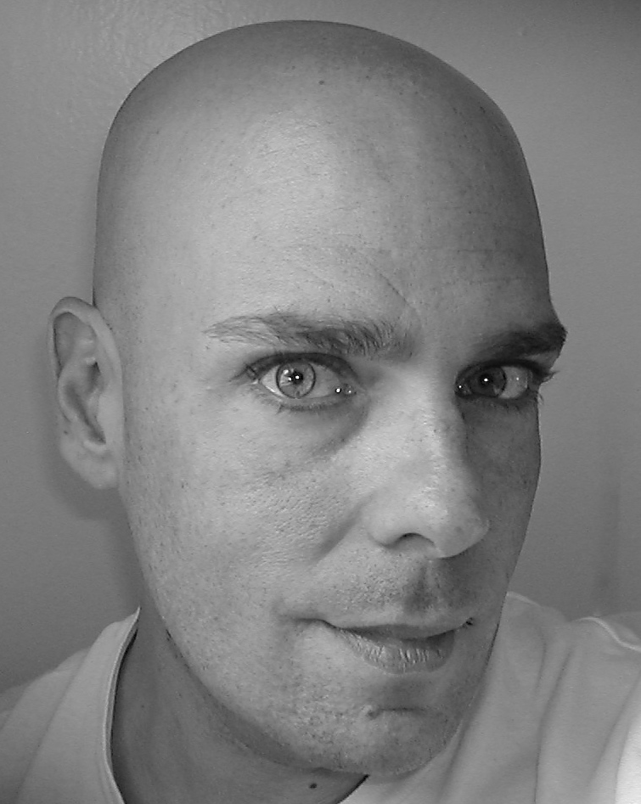
Brendan Constantine is a poet based in Hollywood, California. His work has appeared in FIELD, Zyzzyva, The Pinch, Ploughshares, Ninth Letter, Rattle, and other journals. His most recent collections are Birthday Girl With Possum (2011 Write Bloody Publishing) and Calamity Joe (2012 Red Hen Press). An ardent supporter of Southern California’s poetry communities and one of its most recognized poets, Brendan is currently poet in residence at The Windward School in West Los Angeles. In addition, he regularly presents poetry workshops to hospitals, foster care centers, and with the Alzheimer’s Poetry Project.
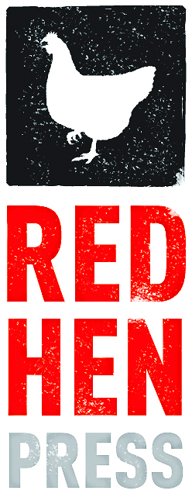
Red Hen Press
P.O. Box 40820
Pasadena, CA 91114
626-356-4760
www.redhen.org
twitter.com/RedHenPress
facebook.com/RedHenPress

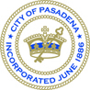

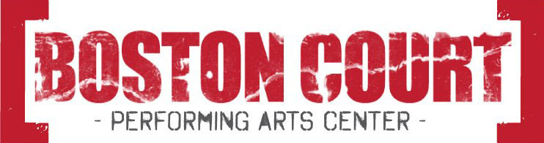
70 North Mentor Avenue
Pasadena, CA 91106
(626) 683-6883
www.bostoncourt.org

4182EV
Made possible in part by the
Pasadena Arts & Culture Commission
and the City of Pasadena Cultural Affairs Division

70 North Mentor Avenue
Pasadena, CA 91106
(626) 683-6883
www.bostoncourt.org

