For Rent:
Cozy Wood Streets “Granny Flat” Studio Apartment
Separate from main house, very quiet and peaceful, no shared walls with neighbors
Kitchen with gas range and ¾ bath, refrigerator included
Air conditioning, heat and ceiling fan. Small deck.
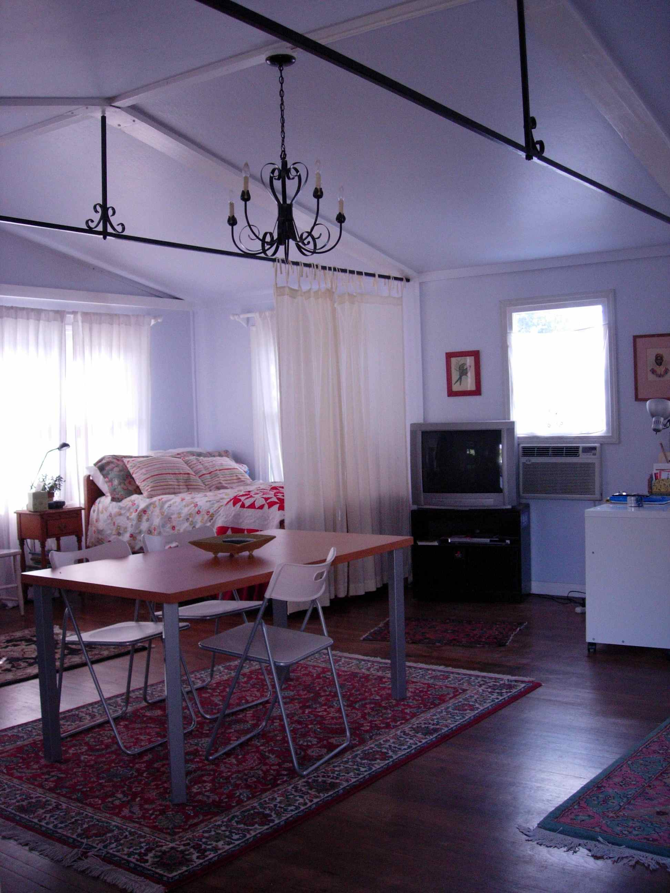
Cable TV with movie channels, hi-speed wifi included
Water, trash, natural gas and sewer included.
Very close to the Riverside Plaza and major bus lines
Peaceful, safe and friendly neighborhood

We are a small family with two young children and are looking to rent our apartment to a quiet, serious and polite graduate student. No smokers or pets.
$500 security deposit, $650 a month. Serious inquiries only please
Email Patricia: ppalagi@gmail.com or text to 951-217-5323
