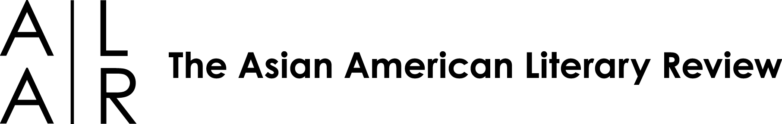

FOR IMMEDIATE RELEASE
CONTACT: Gerald Maa, Editor-In-Chief, The Asian American Literary Review
512.577.1204 editors@aalrmag.org www.aalrmag.org

ASIAN AMERICAN LITERARY REVIEW HOLDS FIRST WEST COAST SYMPOSIUM
IN LITTLE TOKYO, LOS ANGELES

When: May 7, 10 a.m. to 5:30 p.m.
Where: Japanese American National Museum, 369 E. First St., Los Angeles
FREE TO THE PUBLIC

Renowned and emerging Asian American writers will converge at the Japanese American National Museum on May 7 for a day-long celebration of contemporary literature.

8+1: A Symposium, Voices from the Asian American Literary Review will feature Joy Kogawa (Obasan), Kip Fulbeck (Part Asian, 100% Hapa), Rishi Reddi (Karma and Other Stories), R. Zamora Linmark (Leche, Rolling the R’s), Reese Okyong Kwon (short fiction writer, recently named one of Narrative’s “30 Below 30” writers), Viet Nguyen (Race and Resistance: Literature and Politics in Asian America), Hiromi Ito (Killing Kanoko) with award-winning translator Jeffrey Angles, Ray Hsu (Cold Sleep Permanent Afternoon) and Los Angeles native Brian Ascalon Roley (American Son).

These writers reflect the richness and complexity of the Asian American literary landscape. With family roots in Japan, India, the Philippines, Korea, China, and Viet Nam, these writers touch upon fluid identities and communities, erased histories, and linguistic and cultural alienation. Their work ranges from delicate to expressive, experimental to moral.

The symposium will include paired readings, Q&A sessions and book signings. The public may attend any or all of the readings.

Event sponsors include: Japanese American National Museum, UCI Center for Writing and Translation, USC Asian American Studies Program, UCLA Asian American Studies Center, UCLA English Department and UCLA Friends of English, Vietnamese American Arts & Letters Association, Coffee House Press, Hyphen Magazine, Philippine Expressions Bookshop, Kaya Press, Diasporic Vietnamese Artists Network, Giant Robot, Asian American Journalists Association—Los Angeles Chapter, Audrey Magazine, Asian Arts Initiative, Calypso Press, Asian Pacific American Studies at Loyola Marymount University, Asian Pacific American Librarians Association, and Japan America Society of Southern California. This event is supported by Poets and Writers, Inc. through a grant it has received from The James Irvine Foundation.

For a symposium schedule and full author bios, visit http://www.aalrmag.org/symposium/.

About The Asian American Literary Review
The Asian American Literary Review, Inc. (AALR) is a 501(c)(3) nonprofit literary arts organization, a space for those who consider the designation “Asian American” a fruitful starting point for artistic vision and community. We are committed to inclusion and community-building; we are committed to exploring where our many communities are going—our ever-evolving social realities and imaginative possibilities.

