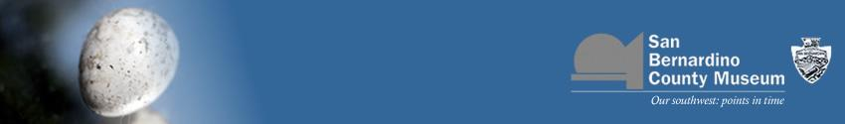
Free discussion every 2nd Wednesday @ 7:30pm. Everyone is welcome
NEW: Afternoon Discussion Group
2nd Fridays of EVEN MONTHS, 2:00 pm, also FREE!
Come to either discussion to share your thoughts, gain a new perspective, or just listen!

February 9 – Seashore Life of Southern California New and Revised Edition by Sam Hinton; AND Under the Sea Wind by Rachel L. Carson (1941) This is Carson’s first book, also said to be her favorite.
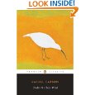
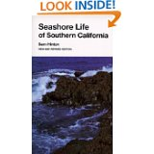
***FIELD TRIP!! Saturday March 19 –
for tidepooling; details TBA
These two quick-reads offer different and compelling views
of the seashore environs.

Afternoon discussion group Friday February 11, 2:00; discuss the January and February titles (The January book was: The Fate of the Mammoth: Fossils, Myth and History by Claudine Cohen – come even if you haven’t read it!)
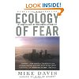
March 9 – Ecology of Fear: Los Angeles and the Imagination of Disaster by Mike Davis
**** AUTHOR PRESENTATION!! Sunday March 6, 2:00 pm.
Come listen to an informal presentation by the author,
and have your book signed.
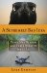

April 13 – A Supremely Bad Idea: Three Mad
Birders and their Quest to See it All by Luke Dempsey
Bring your field guide and be prepared to laugh!

“Dempsey really knows his birds and his birding, which makes him something
of an avian name-dropper.” – Natural History Magazine

Afternoon discussion group Friday April 8, 2:00;
discuss March and April titles

Join the open discussions to share perspectives and insights on science, history and local interests. Reading Discoveries features contemporary and classic topics in natural & cultural history. For more information contact Jolene Redvale (909) 307-2669 ext 252; or jredvale@sbcm.sbcounty.gov
>>>> San Bernardino County Museum Education Center <<<<
2024 Orange Tree Lane, Redlands; California St exit off I-10
Join our open discussion as we share perspectives and
insights on science, history and local interests.
Reading Discoveries features contemporary and classic topics in natural & cultural history.

