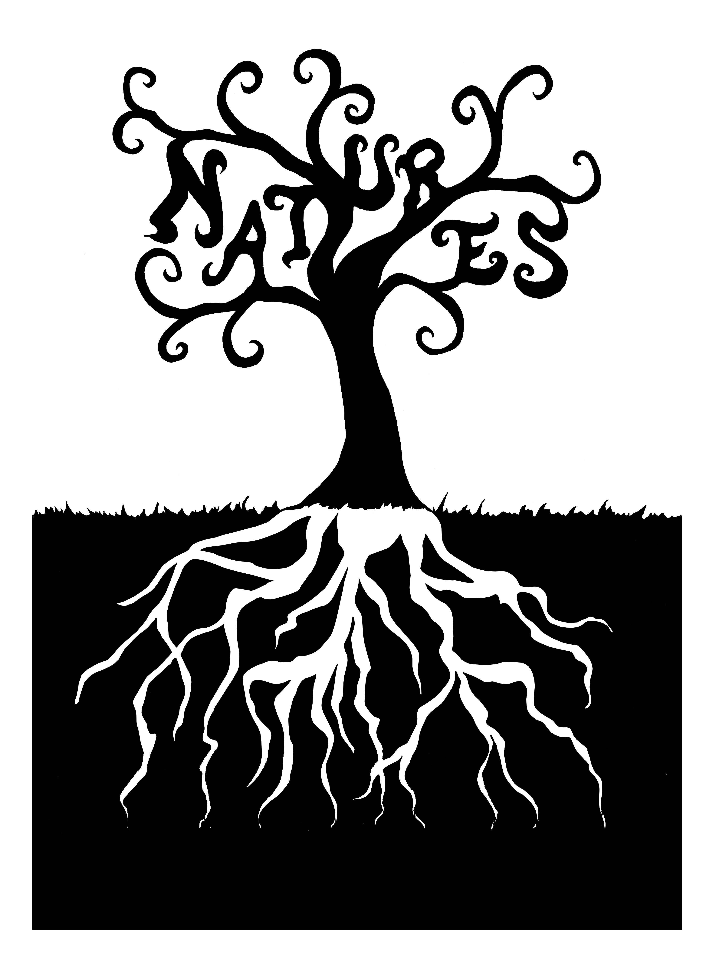
Natures 2011
February 18, 2011
La Sierra University
Textual Politics:
Inspiration, Influence, Interpretation

Graduate students from the humanities and social sciences are encouraged to submit 250 word abstracts on a wide range of topics related to the explication of texts. “Texts” are understood to include any of the following mediums: visual, written, physically constructed, filmed, performed, naturally occurring, manicured, or exhibited. Accepted presentations of 15-20 minutes will be of a critical, analytical nature. Abstracts are due by Friday, Dec. 3 at gradengl@lasierra.edu.
Paper topics might include, but are not limited to:

Textual Politics:  - Inspiration: the power politics of textual creation  - Influential forces on textual production and reception  - Interpretive acts: from close readings to metacriticism  - Breaking Good: the politics of interstitial, intragenre, and agenre texts  - The publication history of a text  - Politics within Texts: the ‘isms embedded within texts  - Canon creation and deconstruction | Ecocriticism:  - Concrete Jungles: The Nature of Cities and Urban Texts  - Nature writing/Natures rites  - The history and depiction of the environmental movement (e.g. DDT, Rachel Carson, global climate change, new energy)  - Can the subterranean speak? The problem of nature’s silence in ecocritical approaches to reading culture.  - The environment in paranormal, fantastic, and science fiction texts

Natures 2011 Distinguished Speaker, Professor J. Scott Bryson (Mount St. Mary’s College), will speak on “Los Angeles Literature” and on his journey from ecocritic of traditional nature writing to specialist in the urban literature of Los Angeles.

