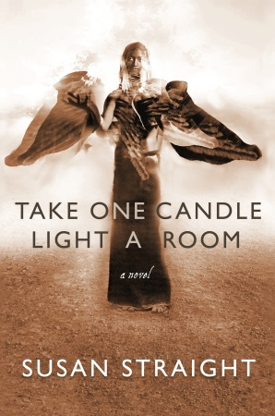

Come to my book launch for
Take One Candle
Light a Room
at Skylight Books
1818 N. Vermont Ave
Tuesday Oct 12, 7:30 pm.
Caramel cupcakes and more!

