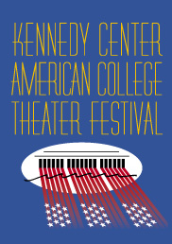

KCACTF provides new playwriting opportunities

As a bonus for entering a production this year, any school that enters either an Associate or a Participating production is eligible to enter as many student-written scripts as they want for reading awards (subject to a limit of no more than two scripts per student per category) with no additional fee.

GET YOUR ORIGINAL STUDENT
PLAYWRITING ENTRIES IN NOW!

For additional information, or if you have questions, contact the National Playwriting Program chair in your region.

And please HURRY! Entry deadline for many playwriting categories is November 1 or EARLIER!
(See regional websites for entry instructions and deadlines!)

Thank you for your entries and your participation in
the Kennedy Center American College Theatre Festival!

