MFA Potluck

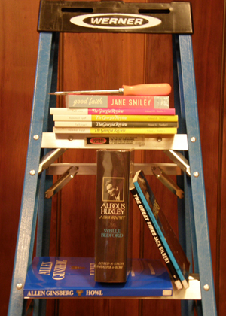

Who: MFA Students and Faculty
When: Friday, September 25 5-9 p.m.
Where: Susan Straight's House
5083 Brockton Ave.
(btwn Magnolia Ave. and Palm Ave. in Riverside)

First Years: Main Dish
Second Years: Salad/Drinks
Third Years: Dessert/Drinks

See you there!

