
CALL FOR SUBMISSIONS

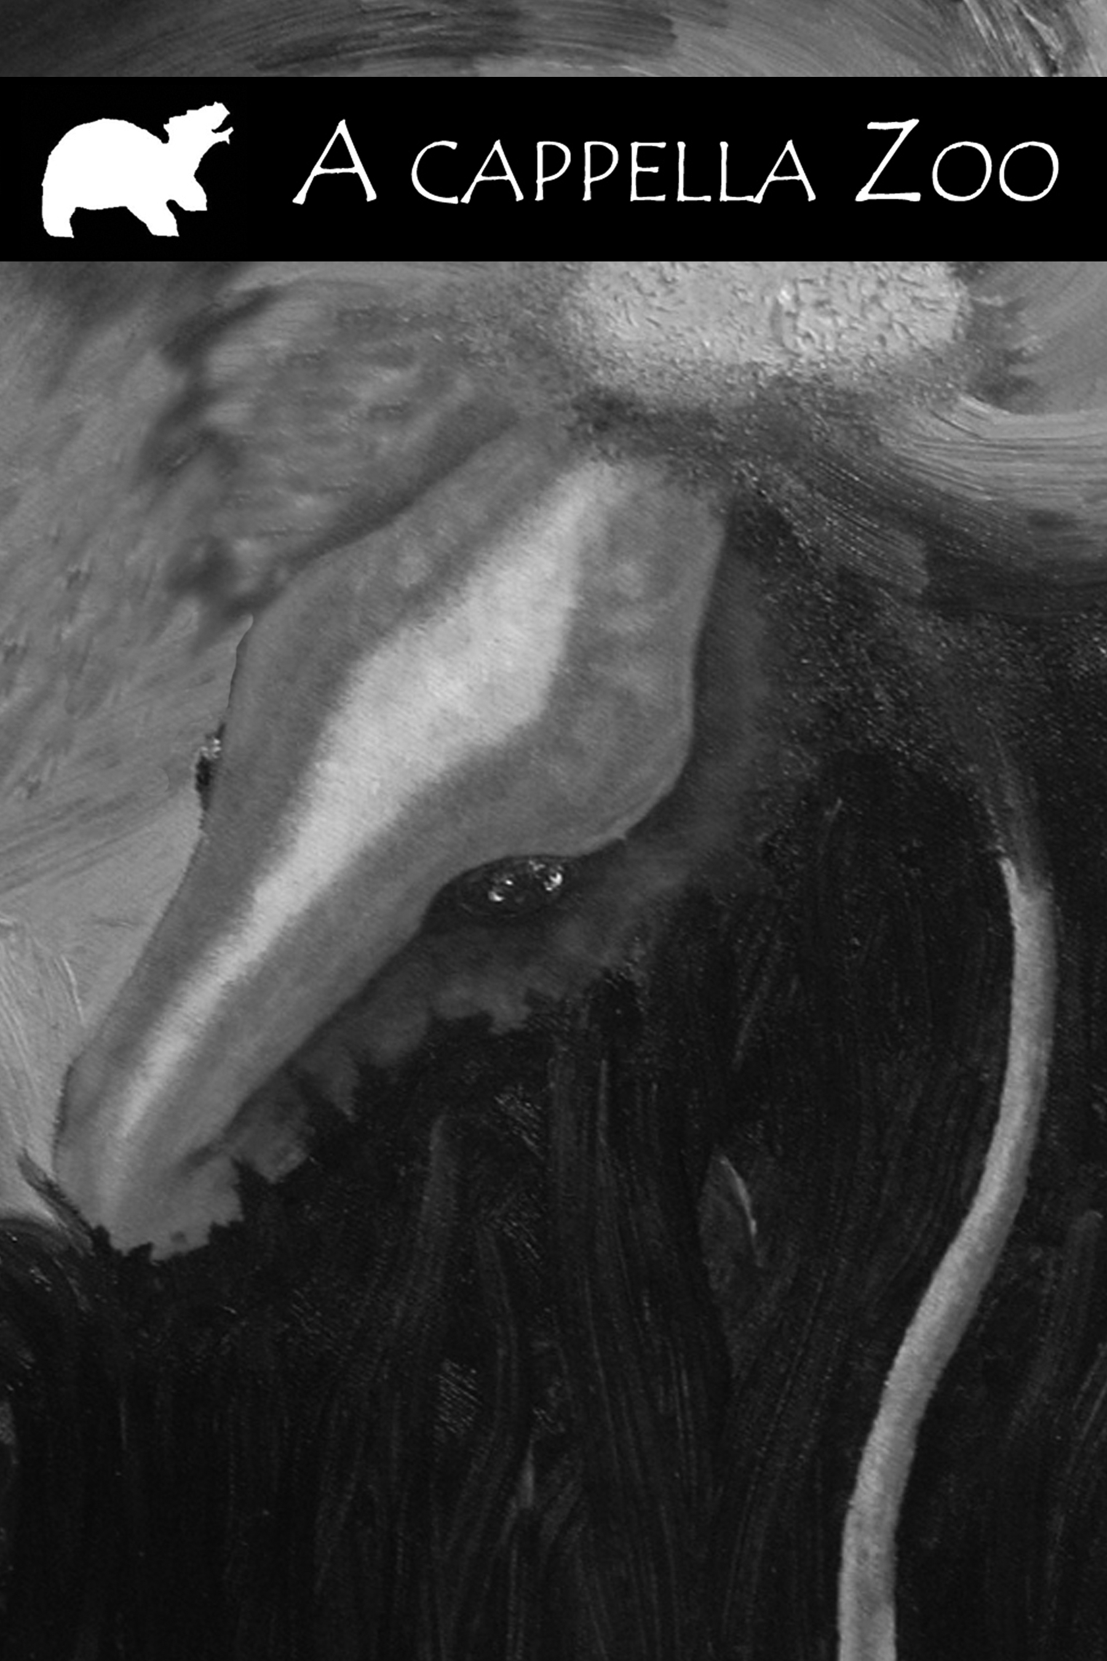

ORIGINS CONTEST
Deadline: July 31, 2008
Fiction: 1,000-10,000 words
First Place Prize: $250

A cappella Zoo has begun its first issue.

Beginning May 1st, we invite submissions of fiction, poetry, plays, creative nonfiction, photography, art, and genre-confused works of all creative kinds: up to 10,000 words of prose or up to 3 poems or visual works. We are especially excited about experimental fiction, magical realism, and bilingual works. Simultaneous and electronic submissions are acceptable and we currently pay $5 per page. Guidelines are available online.

A CAPPELLA ZOO
635 ½ East Benton Street
Pocatello, ID 83201

www.acappellazoo.com

