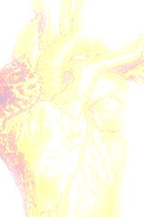
Playwrights @ the Loft

Before and After
Rebel Swarm ~ Abbie Bosworth
Wish of an Almost Widow ~ Molly Gross
As Judas Waits in Purgatory ~ Rob Rinow
One Final Moment ~ Val Stulman
The Flying Henchman ~ Jessi Sundell
Broken Eggshells ~ Kandie StGermain

Program Director: Abbie Bosworth

Directors: Bethany Kraemer,
Majd Murad and Kandie St.Germain

Actors: Jo Dierdorff, Matt Niccum,
Allana Mathias, Yuri Daniels, Mia O'Neill
and Rhaechyl Walker

The Mitten Building
345 N 5th Street Redlands, CA
For more information call (909) 793-1294

May 14 @ 7:15

