News
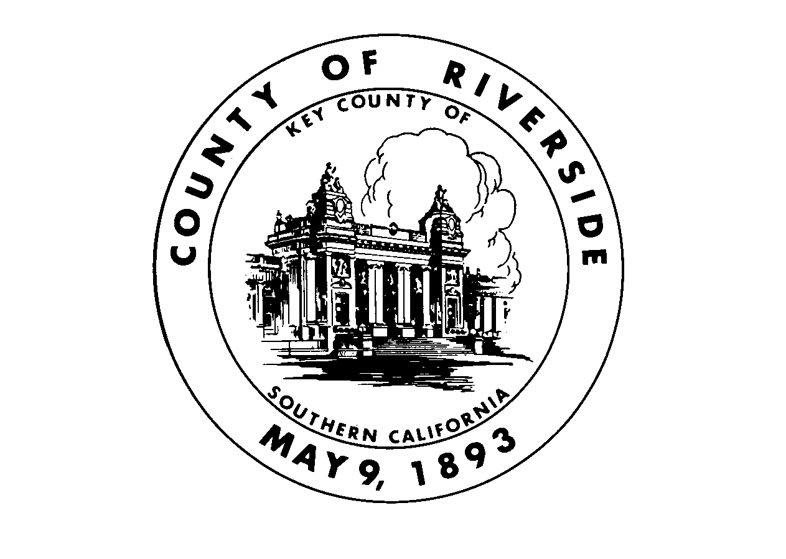

Release

County of Riverside

Release date: 10/29/2007
Contact: Nancy L. Johnson
County Librarian
(951) 955 - 1111

E-Mail: nljohnson@rceo.org

Best-selling author SUSAN VREELAND

brings famous Renoir painting to life !

Palm Desert Public Library 11-14-07

The public is invited to a free literature-and-art program by the highly entertaining author Susan Vreeland at Palm Desert Public Library (73-300 Fred Waring Drive, Palm Desert 92260) on Wednesday, November 14, 2007.

Starting at 6:00 pm in the Library’s Community Room, Susan Vreeland will present her new novel, Luncheon of the Boating Party, along with projected images of Impressionist paintings, painters, models, and donors who play major roles in the book. The internationally best-selling author of Girl in Hyacinth Blue, The Passion of Artemesia, and Forest Lover, Vreeland focuses here on Auguste Renoir’s large painting –whose title is the same as the title of the book- showing a group of happy people enjoying their leisure time on the terrace of a riverside restaurant. As the story unfolds, we get to know each of these characters, as well as the painter himself who puts his reputation on the line with this daring new creation. Using colorful language and solid research, the author herself paints a vivid group portrait of both Renoir, the artist, and his era.

To complement her presentation of words and images, Susan Vreeland will also play some of the music that the Impressionists enjoyed. The author will chat with the audience and sign copies of her books, which will be available for purchase at the event. Refreshments will be provided thanks to the generosity of the Friends of Palm Desert Public Library.

There is no charge for this program, which is open to everyone. Students welcome.
As space is limited, reservations are requested. (760) 346 – 6552 x 253 or www.rivlib.com

Photos and Flyer attached
For more information

Susan Vreeland, www.susanvreeland.com , susan@svreeland.com

Mary Arnold, Special Events Coordinator, Palm Desert Public Library (760) 346 – 6552 x 253
Mary_pld@riverside.lib.ca.us

