Get On Up!
Artists and Writers Against The War
Thursday May 31st from 6:30-8:30 pm
UCR ARTS Building, Screening Room 335
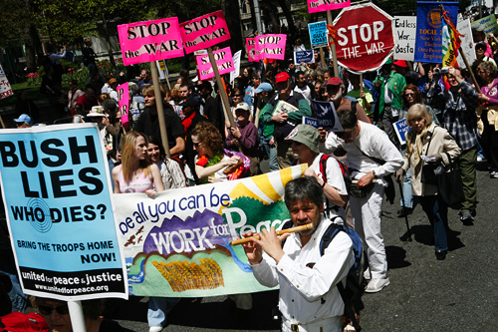
An Evening of Poetry, Story Telling, Performance, and Music Featuring the Original Work of UCR Creative Writing MFA Students and Special Guests

For more info contact Amalia Alvarez amalia.alvarez@email.ucr.edu

