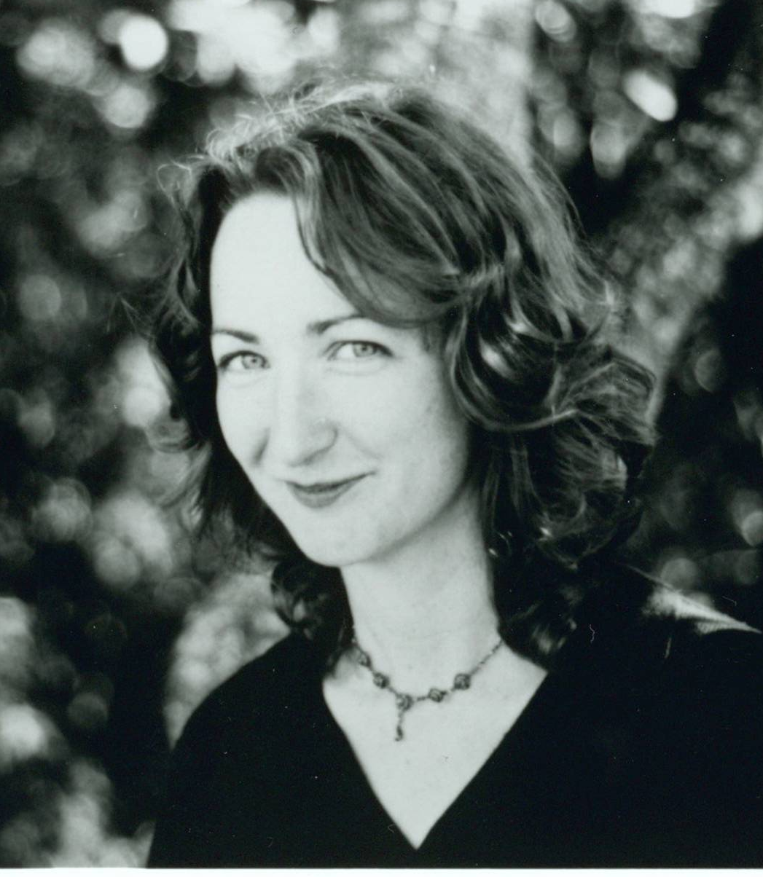
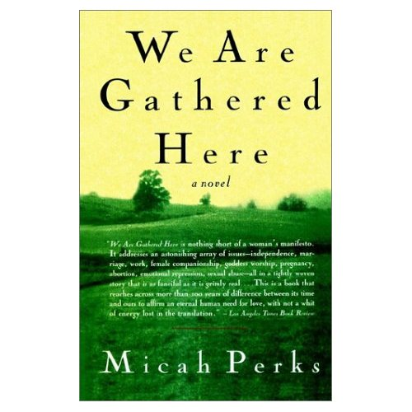
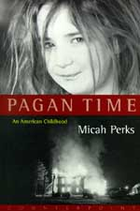
The Department of Creative Writing Presents

Micah Perks
Tuesday, November 7, 2006
04:30 - 5:30 PM

1500 HMNSS
Micah Perks is the author of the memoir, Pagan Time. She has been nominated twice for a Pushcart Prize. She is also the author of the novel, We Are Gathered Here. She lives in Santa Cruz with her two children, where she teaches Creative Writing at the University of
California, Santa Cruz.

“Perks’s breakneck memoir of her childhood on a commune in the Adirondacks is a vigorous, dead-on portrait of the joy and confusion of counterculture life in microcosm”
- Publishers Weekly
“This brilliantly original account of growing up in a New Age commune in the sixties will make some raders happy that they weren’t there with Micah Perks and her eccentric, extended family, and others will wish they had been—but all will be amazed, amused, and impressed.”
- Alison Lurie

