WHITTIER COLLEGE WRITERS FESTIVAL, 2006!

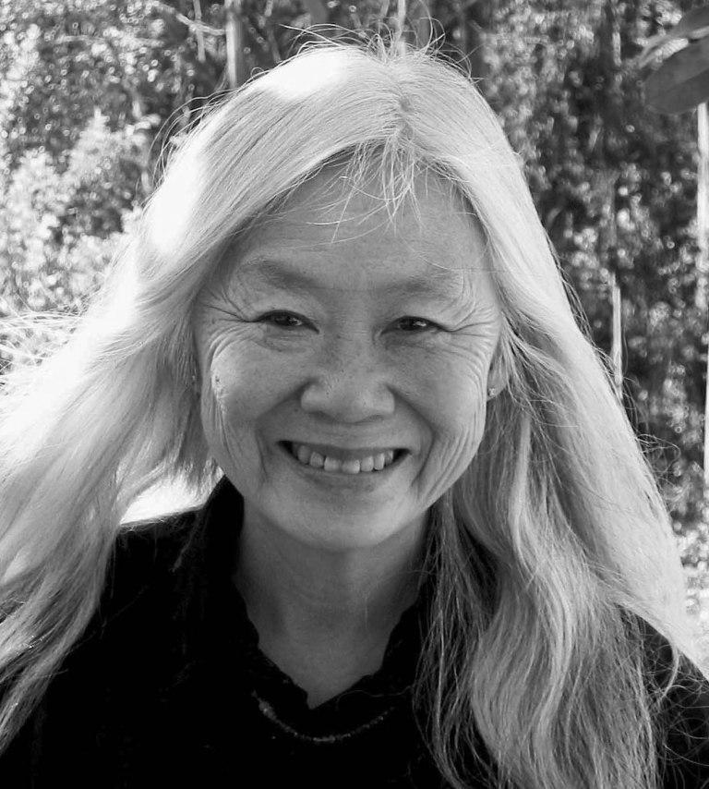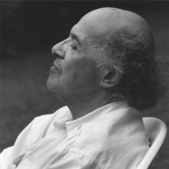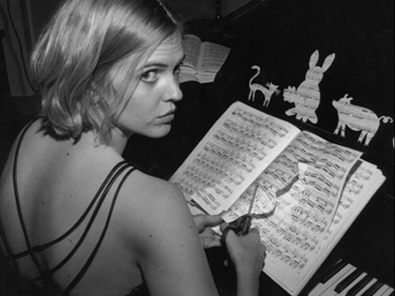
Maxine Hong Kingston Gerald Stern Oni Buchanan

Come see internationally praised poets and writers, including Maxine Hong Kingston, Gerald Stern, and Oni Buchanan read their work and answer your questions!

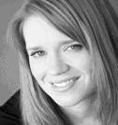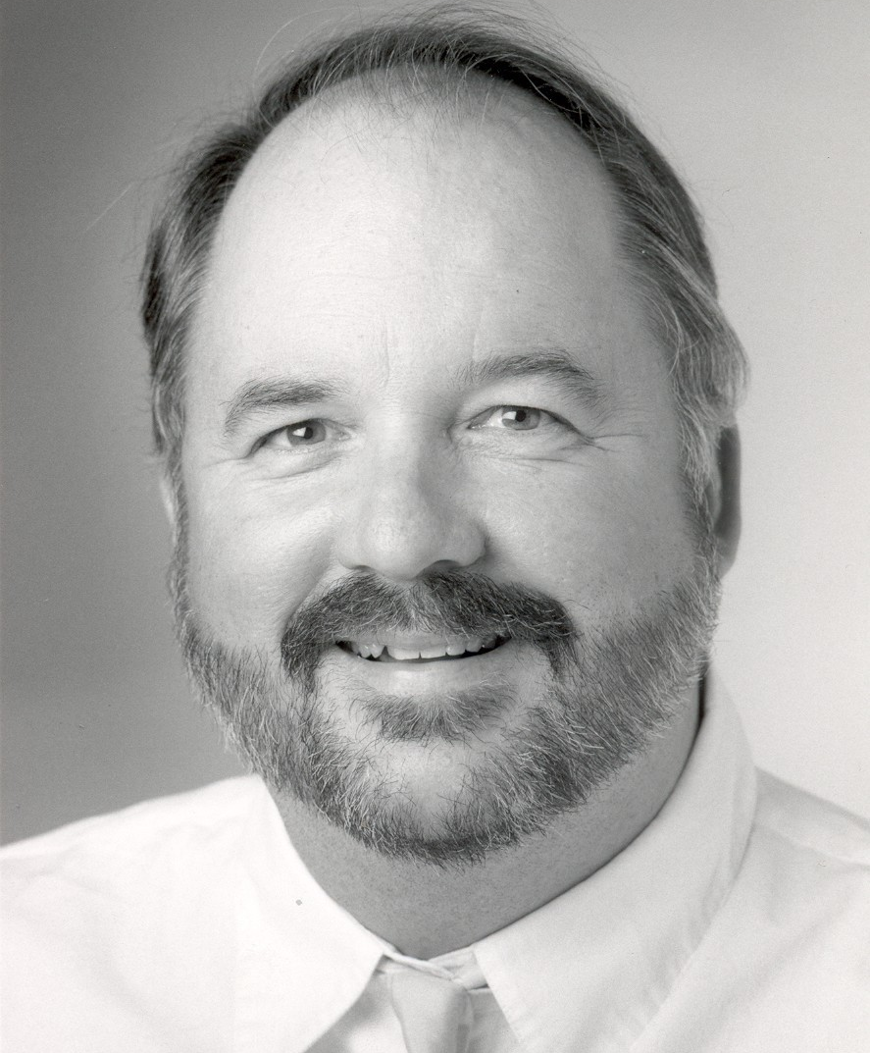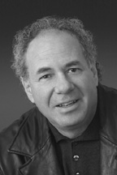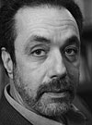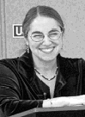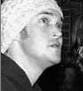
Emily | Christopher | Stuart | Frank | Maurya | Mike
Rapp | Buckley | Dischell | Gaspar | Simon | the Poet

Monday, October 2

5 p.m.-6 pm Memoir readings by Christopher Buckley and Emily Rapp

7:30-9 p.m. Maxine Hong Kingston, reading/talk, followed by Q&A
Tuesday, October 3

5 p.m.-6 p.m. Fiction reading by Frank Gaspar and Poetry reading by Stuart Dischell

7:30-9 p.m. Poetry reading and Q&A by Gerald Stern

Wednesday, October 4

5 p.m.-6 p.m. Poetry and Spoken Word readings by Maurya Simon and Mike the Poet

7:30-9 p.m. Piano and Poetry performance by Oni Buchanan

Price: $6/day, $10 for 2-day pass, or $15 for all three days (free for Whittier College students and employees). Buy tickets at: www.shannoncenter.org, tel: (562) 907-4203

Location: The Shannon Center, Whittier College (see www.shannoncenter.org for directions)
Contact: Marilyn Chavez (mchavez1@whittier.edu) or The Shannon Center Box Office
(boxoffice@whittier.edu)

