The Department of Creative Writing Presents

Lee Gutkind

Tuesday, May 2, 2006
3:30 - 5:30 PM

1500 HMNSS

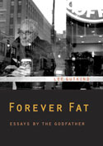
Lee Gutkind is the founder and editor of the journal Creative Nonfiction. The author and editor of a dozen books, including the award-winning Many Sleepless Nights: The World of Organ Transplantation, he is a professor of English at the University of Pittsburgh and the director of the Mid-Atlantic Creative Nonfiction Writers’ Conference at Goucher College.

