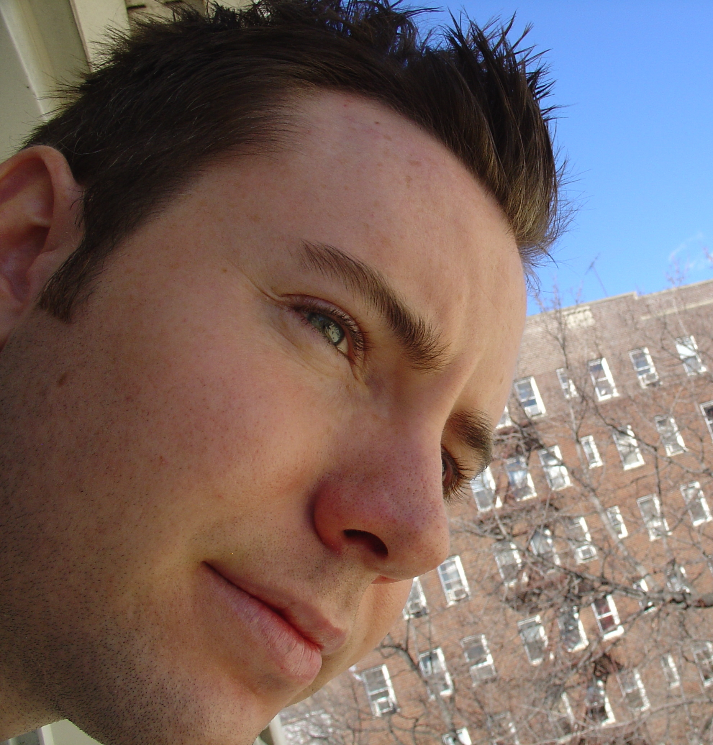
Adam Davis received his BA in Creative Writing from the University of California, Riverside and his MFA in Poetry from Columbia University, where he was the William Brock-Broido Fellow. His work has appeared or is forthcoming in The Paris Review, Guernica, Western
Humanities Review, Logos, Mosaic, and in a collection of ekphrastic verse, The Eye of the Beholder: A Poet's Gallery. He currently lives in
Brooklyn.

The Department of Creative Writing Presents

Poet

Adam Davis
Tuesday, May 9, 2006
3:30 - 5:00 PM

1500 HMNSS

