UCR FRENCH PROGRAM PRESENTS
TOURNÉES FESTIVAL
CONTEMPORARY FILMS BY FRENCH WOMEN

TUESDAYS IN MAY 2006
7:30
UNIVERSITY VILLAGE CINEMAS
RIVERSIDE, CA

5/2: Delphine Gleize’s Carnages
5/9: ClairE Denis’s The Intruder
5/16: Valeria Bruni Tedeschi’s It’s Easier for a Camel
5/23: Julie Bertuccelli’s Since Otar Left
5/30: Catherine Breillat’s Sex is Comedy

$7 General Admission
$5 Students and Seniors with ID
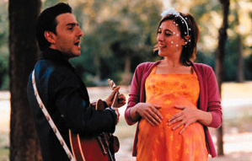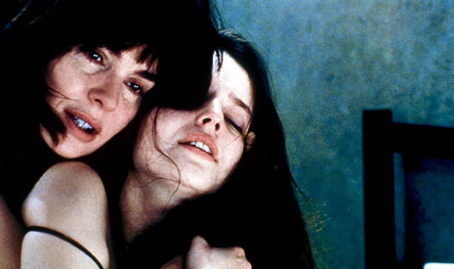

Cosponsored by the UCR departments of Comparative Literature &Foreign Languages, Hispanic Studies, and Women’s Studies,
and the Program in Film & Visual Culture.
The Tournées Festival is made possible with the support of the Cultural Services of the French Embassy and the French Ministry of Culture (CNC).

