Winter Colloquium 2006
Department of Comparative Literature

Hypermedia Berlin

Talk by

Todd Presner (UCLA):

“Remediating Benjamin and Kracauer,
or the City in the Age of New Media”

Wednesday, March 1st
12:10 – 1pm
HMNSS 2412

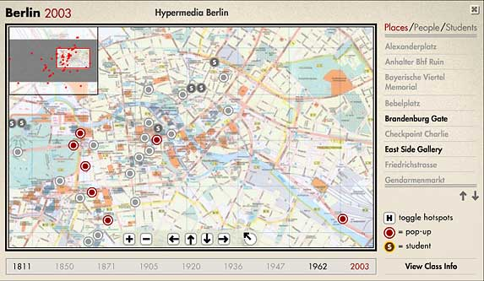"Hypermedia Berlin" is an interdisciplinary, multimedia, web-based research and curriculum development project, which investigates, analyzes, and maps the cultural, architectural, and historical layers of a city space.

