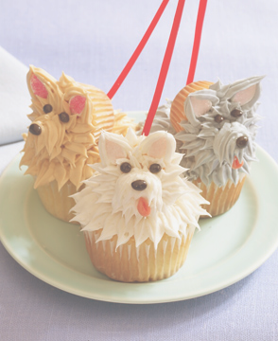
Cupcake Wars
April 2, 2012
The Darwin Room
3:00pm-4:30 pm

Bring your cupcake making skills to Lab Prep!!!

Cupcake Wars will be broken down into three separate categories, each category wins a fabulous prize for 1st and 2nd place!!

- Appearance/Creativity (NOT judged on flavor)
- Sugar Added (honey can be used for sugar cupcakes)
- Sugar Free

- You may enter a maximum of 2 different cupcakes in any category

- Please bring a minimum of 12 cupcakes, 1 of the cupcakes will be judged the rest will be for the crowd to enjoy ☺

The Judges this year will be Jacques, Cathy, and Mi Kyong

NO store bought cupcakes are allowed

