Carla Essenberg  Track: Ecology  Advisor: John Rotenberry  Interests: Pollination, competition, facilitation, foraging behavior, and spatial scale  CV | 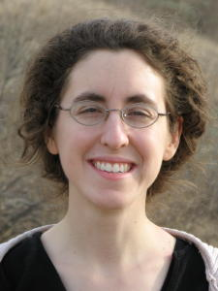

A link to a student’s webpage would be attached to their name and a link to their advisor’s website would be attached to the advisor’s name, and a link to their CV would be attached to “CV” (and “CV” would be omitted if they hadn’t given a CV to Melissa).

