EEOB T-SHIRT AND TOTE BAG DETAILS

T-SHIRTS ($10 each, except for XXL and up):

Shirt colors available: Back design: Left chest design:
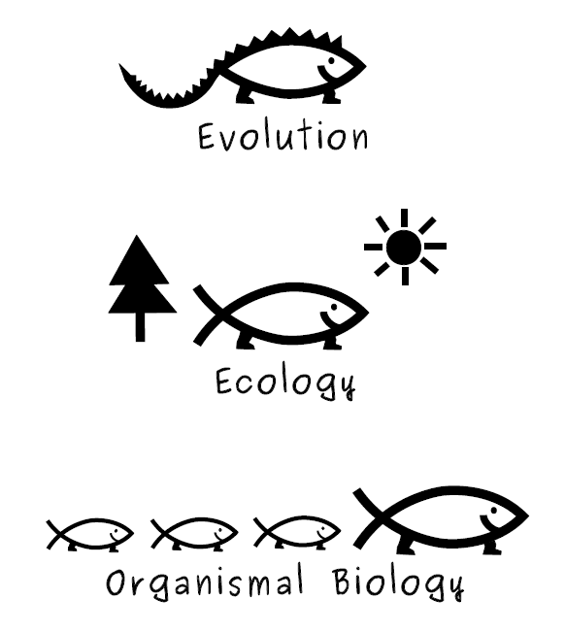

Black

Red

Pink

Light blue

Royal blue

Navy blue Design will be printed in white

Pricing and styles/sizes available (see size chart):

Regular S – XL; larger sizes available for an extra $1/X

Ladies XS - XL; larger sizes available for an extra $1/X

T-shirts are made of heavyweight, 6.1-ounce, 100% cotton.

TOTE BAGS ($10 each):

Bag colors Design (printed
available: in white):
Black

Navy

Hunter green

Tote bags are made of durable, 12-ounce, 100% cotton with reinforced cotton web handles and are 15.5 x 13 x 7 inches.

