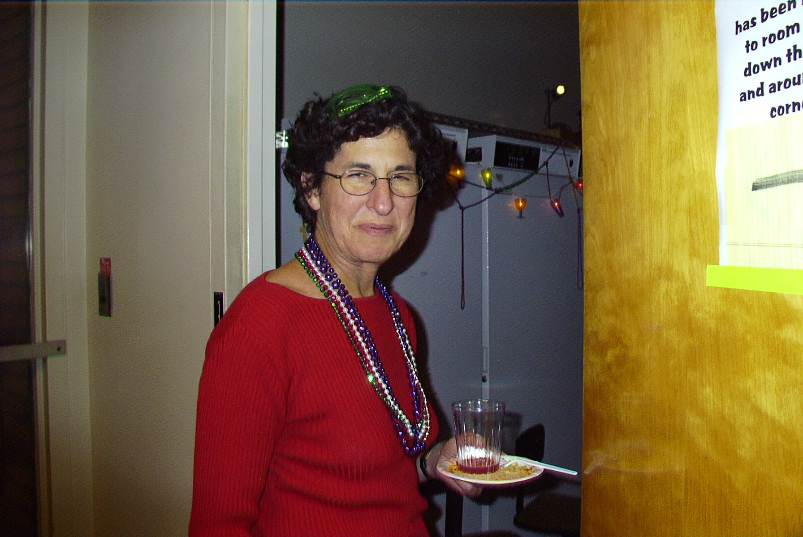
The BNN Fundraising Cookbook

Imagine a party with
no plates, cups, or
utensils.

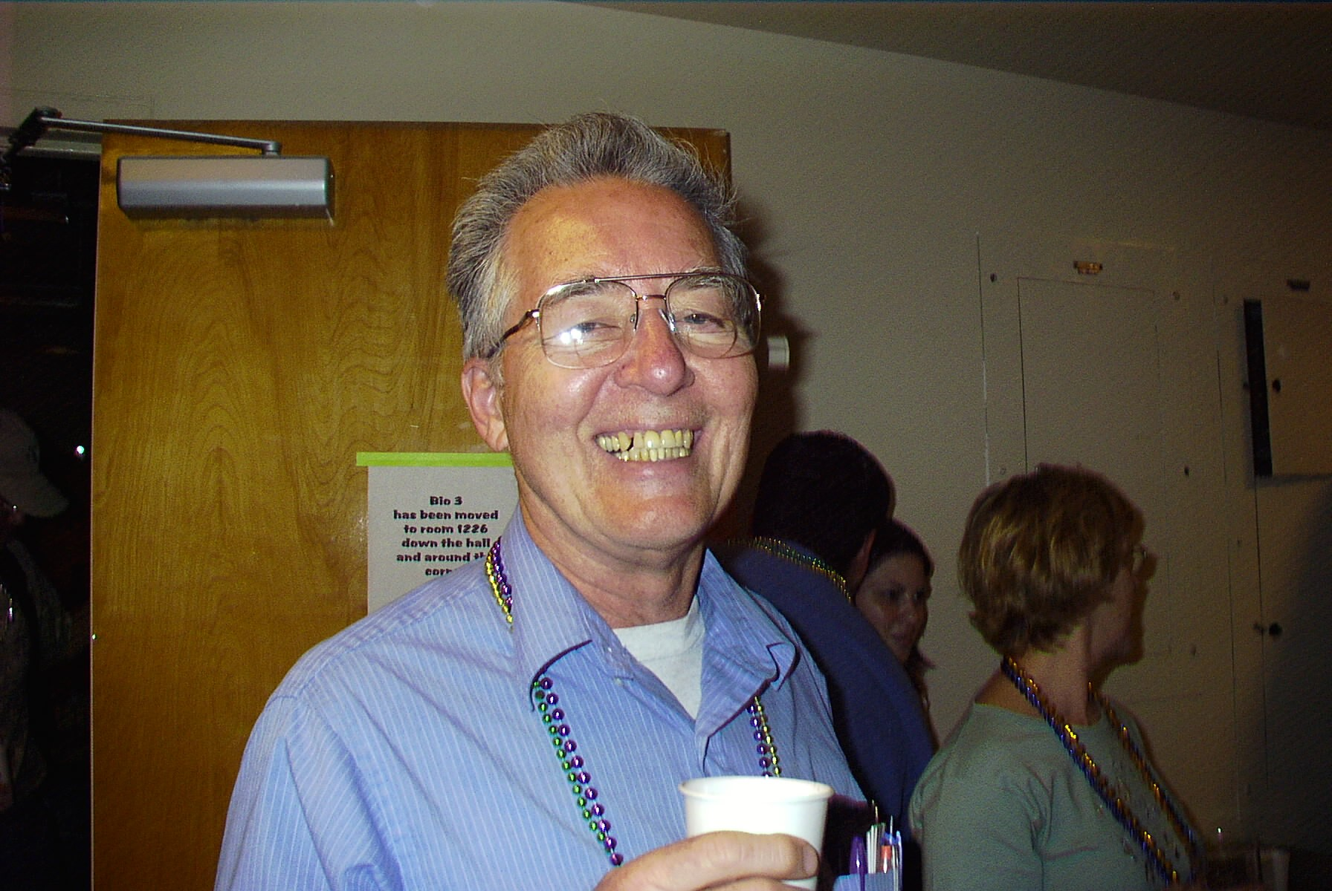

Imagine a gathering with
no shiny beads…
and no napkins.

Please looking into your heart, and kitchen, and submit recipes for the BNN Fundraising Cookbook. For just 10 minutes a day, the time it takes to drink a cup of coffee, you could submit a recipe that will keep these professors smiling, at least for another year. The deadline has been extended to Nov. 15th to accommodate your generous donations.

As before, we are asking all that are willing to submit 3 recipes, a main dish, a side dish, and a dessert. Submissions can be dropped off in Jon Allen’s or Cherysa Cortez’s mailbox in Spieth 1208 or e-mailed to jonallen@ucr.edu or cherysa.cortez@ucr.edu . Paper forms are available in Spieth 1208 and an e-form has been attached to this e-mail

Hunger is the best sauce! - Cervantes

