Online Tag Program (OTP) Manual
(for Waste Generators)
Sign-up First 1
Logging on the Online Tag Program 1
1.Type in the address> http://otp.ucop.edu 1
2. Enter User name and Password. 1
Modify User Settings 1
Creating a Waste Tag 2
1. Click on “Create New Tag”- 2
Containers in Accumulation Areas 4
Containers Ready for Disposal 4
Create New Tag from Profile (for Waste that is generated repeatedly) 5
Waste Profiles 6
Editing A Waste Tag 6
Deleting a Tag 6
On-Line Tag Program (OTP) Sign-Up Form 7

Sign-up First
In order to establish an account on the Online Tag Program, you must first open an account. You can do this faxing the completed sign-up form to (951) 827-5122 or emailing the information requested to Russell Vernon (russell.vernon@ucr.edu). This procedure will provide you with a user name, password and will enable you to use the program. There shall be only one account per Principal Investigator or supervisor that the whole lab or group can use. Once you are signed up, the system will automatically send an email to the addresses designated on the account. This email will be from a sender called “onlinetagprogram@otp.ucsc.edu” and it will contain the login information for that account.

Logging on the Online Tag Program

1.Type in the address> http://otp.ucop.edu
(PLEASE NOTE: THERE ARE NO WWW’S IN FRONT OF THE ADDRESS)

2. Enter User name and Password.

Modify User Settings
To change user settings, Click on “Modify User Settings”. This will enable the user to change passwords, email addresses, phone numbers, safety/waste coordinator, add locations/edit locations and/or remove locations. Click on “Update Settings” at the end of each change made.
**For the first time user, you must change the temporary password to a password that unique for your lab or group. You must have at least one Storage Location in order to proceed to the creation of waste tags.

Creating a Waste Tag

1. Click on “Create New Tag”-
- Choose a “Storage location” (where the waste container will be located while
waste is being accumulated).
“Container Size” is the total volume or weight the waste container can hold at maximum capacity.
NOTE: If dry waste is being disposed of and plastic bags are used as the storage container, then container size is the volume size of the bag not the actual weight of the bag. Trash bags you buy for your home are usually in gallon size.
- “Chemical Constituents”, (the chemicals in the waste container) should be listed according to quantity. Only COMPLETE chemical names should be used and no abbreviations or symbols.
- “Percentage” should correspond to the amount of each chemical that is in the container relative to the total amount. As you change one percentage, the others automatically adjust so that the constituents listed will always add up to 100% of the waste in the container.
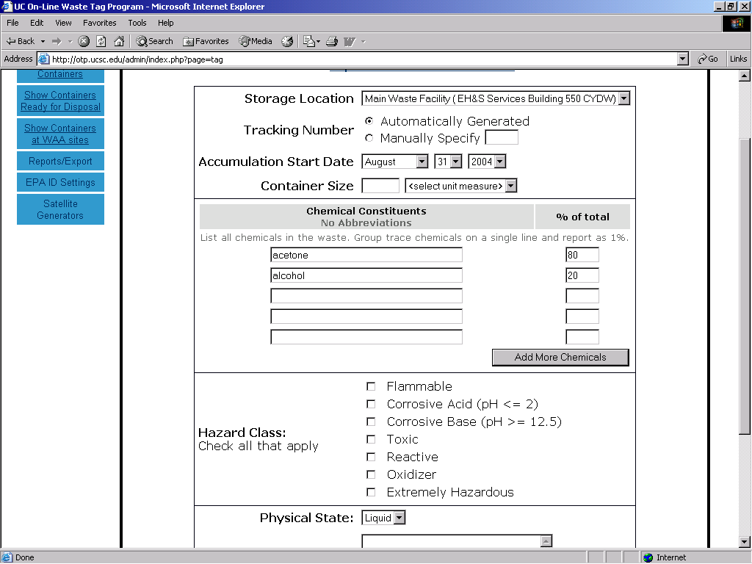
- “Hazard Class” corresponds to how the EPA classifies each chemical based on their primary danger to the environment. The Hazard Class that a chemical waste belongs to can be looked up in the Material Safety Data Sheet (MSDS), or product label.
- “Physical State” is simply whether the waste is solid, liquid, or gas. In the case of two-phase waste, according to the Department of Transportation, even a solid with trace amounts of liquid in it will be classified as liquid waste.
- “Comments” section can be used to inform the waste technicians picking up the container, if there is any special handling information that you feel they would need to know. This section can also be utilized for the labs own internal notes.
When the tag is completely filled out, click on “Save and Print Tag”. Another window should open up in Adobe Acrobat with your new online tag. Please make sure your computer has the most current version of Adobe Acrobat (http://www.adobe.com/products/acrobat/alternate.html#reader602full)

Each tag will have an assigned tracking number unique to that container. Print out the tag, fold it along the dotted line, and place it into one of the clear packing envelopes (provided by Environmental Health and Safety).
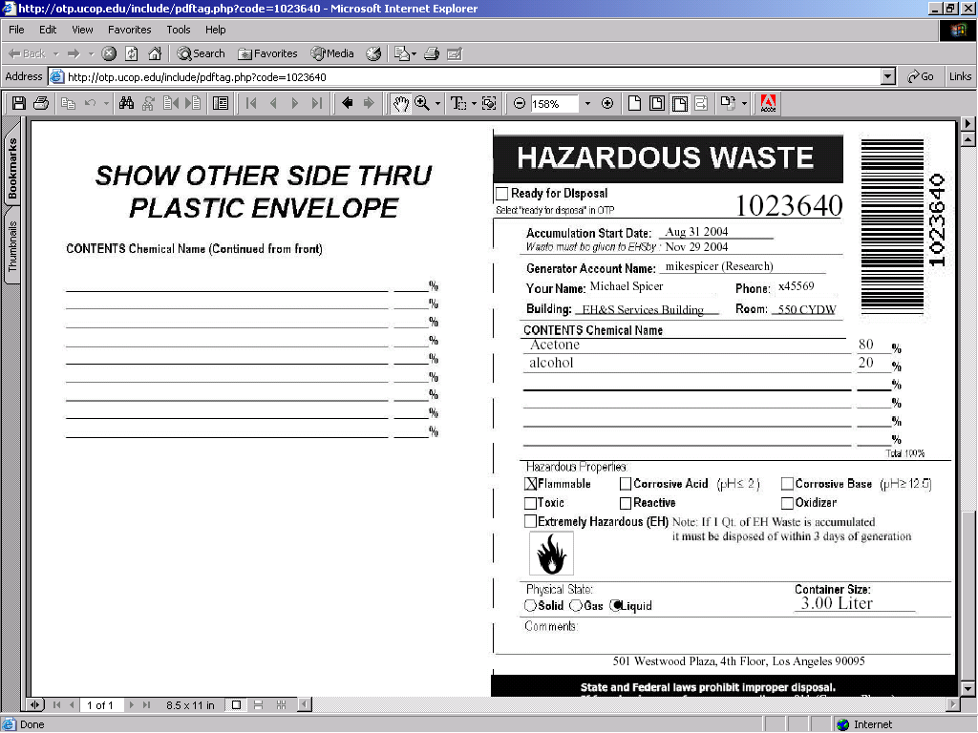
*If you are creating a waste that will be generated routinely, you have the option to click the “Save as Profile” button. This will save all of the chemical constituents with their percentages, the hazard class and physical state. If you click this button, you will move onto the “Waste Profiles” menu. In this case, your tag will not be generated. If you want to create a tag from this new profile that you just set up, please refer to the “Create New Tag from Profile” section of this manual.

Containers in Accumulation Areas
The “Main” menu contains all the chemicals that are currently being stored and accumulated in your lab or accumulation area. It is designated by a tracking number, chemical name, building/ room stored and maximum days held.

Containers Ready for Disposal
Containers that have reached their maximum allowable storage time limits (on the main UCR Campus 180 days) automatically get sent this section. The users with e-mail addresses listed on the account will automatically get an e-mail from the system letting them know that the container is over the allowable storage time limits and needs to be brought to the next pickup.

The lab can also manually send a container to this area when the container is full, or no longer being filled. This action will assist the labs in organizing which waste is ready to be picked-up.

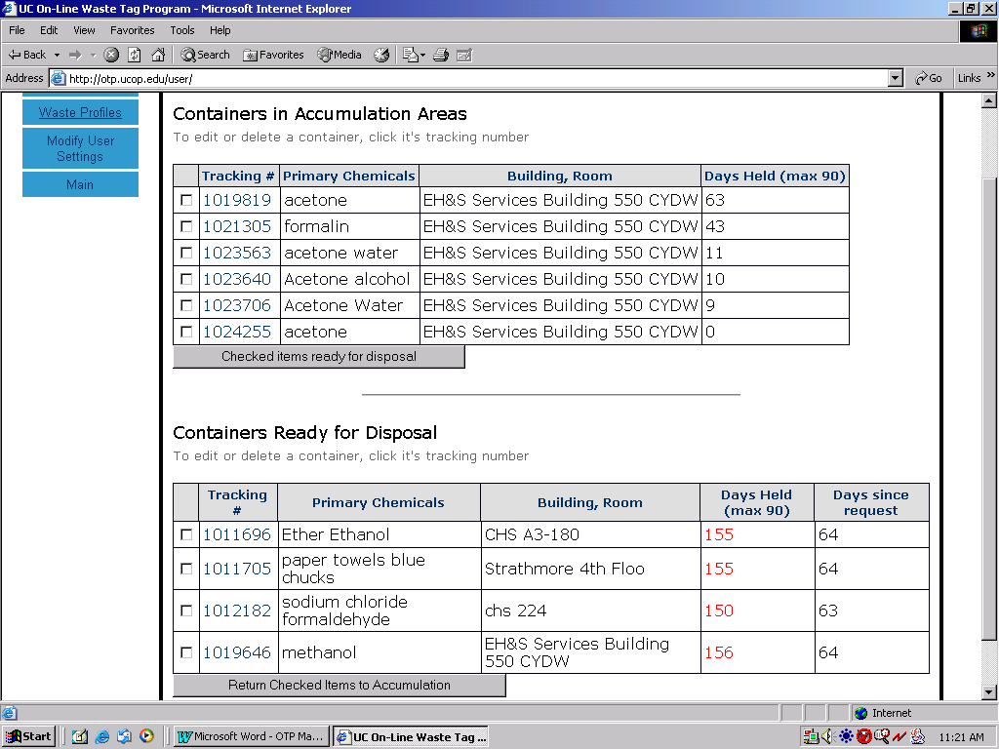

Create New Tag from Profile (for Waste that is generated repeatedly)
This menu will allow you to create a new tag from an existing template or “profile”. Most of the information will already be filled in with exceptions such as “storage location, container size and unit of measure. Chemical constituents and percentages can also be modified.
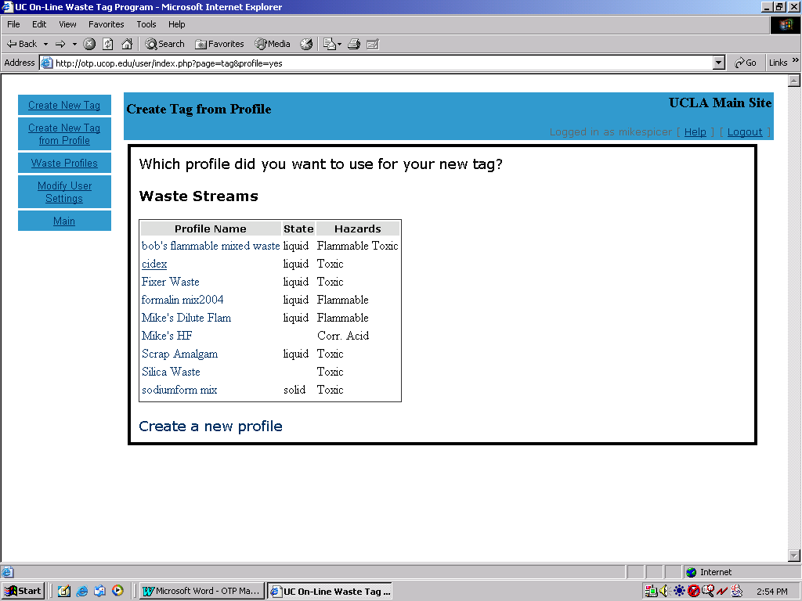-Click on “Create New Tag from Profile. You will see the Waste Streams window and it will ask you which profile you will want for your new tag. Click on one of the profile that matches the profile name and you will be directed the “Create new Tag” window. Usually the “Create New Tag” section is a blank template. Since you entered from the “Create New Tag from Profile” menu, all of the fields are already filled in. All you have to do is select the Storage location, container size, and the units of measure. Once you complete these items, you can click on “Save and Print Tag”.

Waste Profiles
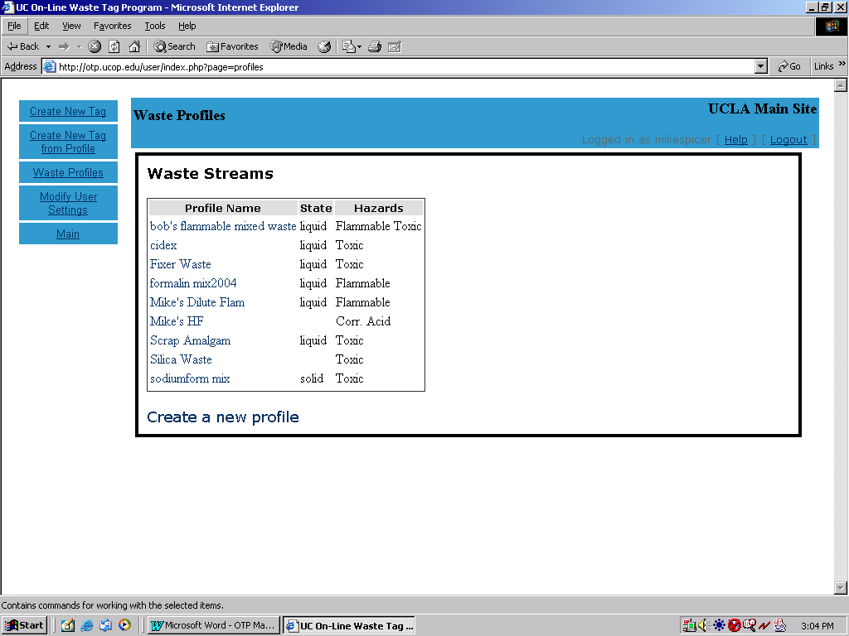
This menu is for creating a template for waste that is generated repeatedly.
Wastes that are generated frequently and repeatedly are listed as Waste Streams. They are listed with their respective profile name, physical state, and hazards.
To create a new profile, click on “Create a new Profile” at the bottom of the “Waste Profiles” window. This will take you to a modified version of the “Create New Tag” menu. Once you fill it out, click on the “Save as Profile” button at the bottom of the page.

Editing a Waste Tag
After you printed your tag. You realized you are going to add something else to the container or if you need to remove a particular compound. By clicking on the container number you go back to that particular waste tag and you can add or remove the compounds in that container

Afterwards you click on the button that says reprint tag and you go back into a pdf window and reprint the tag like before. And replace the tag on the container with the new one.

Deleting a Tag
Click on the tag number and you enter the container screen and click on the delete tag button to remove from your location. Use this feature only to remove a container that you created by mistake or if a container you didn’t actually use.
Do not use this feature to remove containers that haven’t yet been picked-up from your lab’s accumulation area. If you have a problem, please email us or call x25528.

On-Line Tag Program (OTP) Sign-Up Form

The On-line Tag Program (OTP) is the way for UC Riverside generators of chemical waste to fill out tags electronically and print them from their computers. This system is designed to create tags and label hazardous wastes at the moment the waste is generated. This will assist generators to be in compliance with the EPA waste regulations.

All of the user's contact information will be stored and will print on each tag automatically. Waste profiles can be created for recurrent waste streams as well. All of these features are designed to save the generator time while keeping them in compliance with regulations.

There shall be only one account per Principal Investigator or supervisor that the whole lab or group can use.

To get started just fill out the information below.
Preferred Username
(We can’t guarantee it hasn’t been used already)
Preferred Initial Password
(You can change it)
Department *
First Name (PI) *
Last Name (PI) *
E-mail Address (PI) *
Phone (PI) *
Send additional e-mail notification *
Send additional e-mail notification
Lab Waste Coordinator First Name
Lab Waste Coordinator Last Name
Lab Waste Coordinator Phone
 | Primary Activity for Source of Waste: *
 |  |  | □ |  |  |  | Research
 |  |  | □ |  |  |  | Instruction
 |  |  | □ |  |  |  | Facilities
 |  |  | □ |  |  |  | Health Care
 |  |  | □ |  |  |  | Other
Required fields at indicated with an * asterisks

Please fill out and return to:
Russell Vernon, Ph.D., Environmental Health & Safety,russell.vernon@ucr.edu
www.ehs.ucr.edu Direct: (951) 827-5119 Admin: (951) 827-5528
Fax: (951) 827-5122

